1-P9

1. 1 Gbps = 10,000 \* 100kbps ∴ The number of maximum users is 10,000.

Probability is 10%, ∴ The maximum real number of users is 10,000 $0.1$\* = 1,000 = N



$\sum_{N+1}^{M}{ M ∁_{i} p^{i}}{(1-p)}^{M-i}$

1-P26

L = $\frac{M}{R * \frac{M}{S}}$ = $\frac{S}{R}$, d = 2 ${10}^{7}$\* m , R = 2 ${10}^{6}$\* bps,

S =2.5 ${10}^{8}$\* meters/sec

∴ L = m = $\frac{S}{R}$, R = $\frac{2.5 * {10}^{8}[m/sec]}{2 * {10}^{7}[m]}$ = 12.5bps

1-P31

$d_{trans} = \frac{L}{R} = \frac{8 * {10}^{6}[bit]}{2 * {10}^{6}[bit / sec]} = 4 [sec]$

Total 3 time’s store & forward, ∴ 12[sec]

$d_{trans} = \frac{L}{R} = \frac{ {10}^{4}}{2 * {10}^{6}} = 0.5 * {10}^{-2} = 0.005[sec]$

* The first packet is sent immediately to the second switch when the first packet, 10,000 bits, arrives at the first switch.
* After the first packet leaves the destination host, the second packet takes a direct ride on the link.
* After that, the packet arriving at the first switch immediately leaves the second switch when the first packet leaves the first switch.
* The first packet takes 5 [ms] of time to traverse one link. That is, the first packet takes 15 ms to arrive at the destination and the second packet arrives 5 ms later than this, so it arrives at the destination host at 20 ms.

3-P26

1. The size of TCP sequence number field = 4bytes = 32bits

∴ The range of sequence number is $2^{0} \sim 2^{32}-1$ => The maximum file size sent is $2^{32}$ bytes

1. Maximum segment size = 536 bytes

Segment data = ${2^{32}}/{536}$ = 8012999 , Total header fields = 66bytes

Total number of bytes through the 155Mbps link = 8012999 \* 66 = 528857934 bytes

Transmitted data = $2^{32} + 528857934$ = 4.824 ${10}^{9}$\* bytes

Transmit time = ${4.824 * {10}^{9} bytes}/{155*{10}^{9}bps}$ ≒ 249 seconds

3-P27

1. 127+80 / 302 / 80 ∵ First segment is 80.
2. 207 / 302 / 80 ∵First segment is arrived.
3. 127 ∵First segment isn’t arrived.
4. 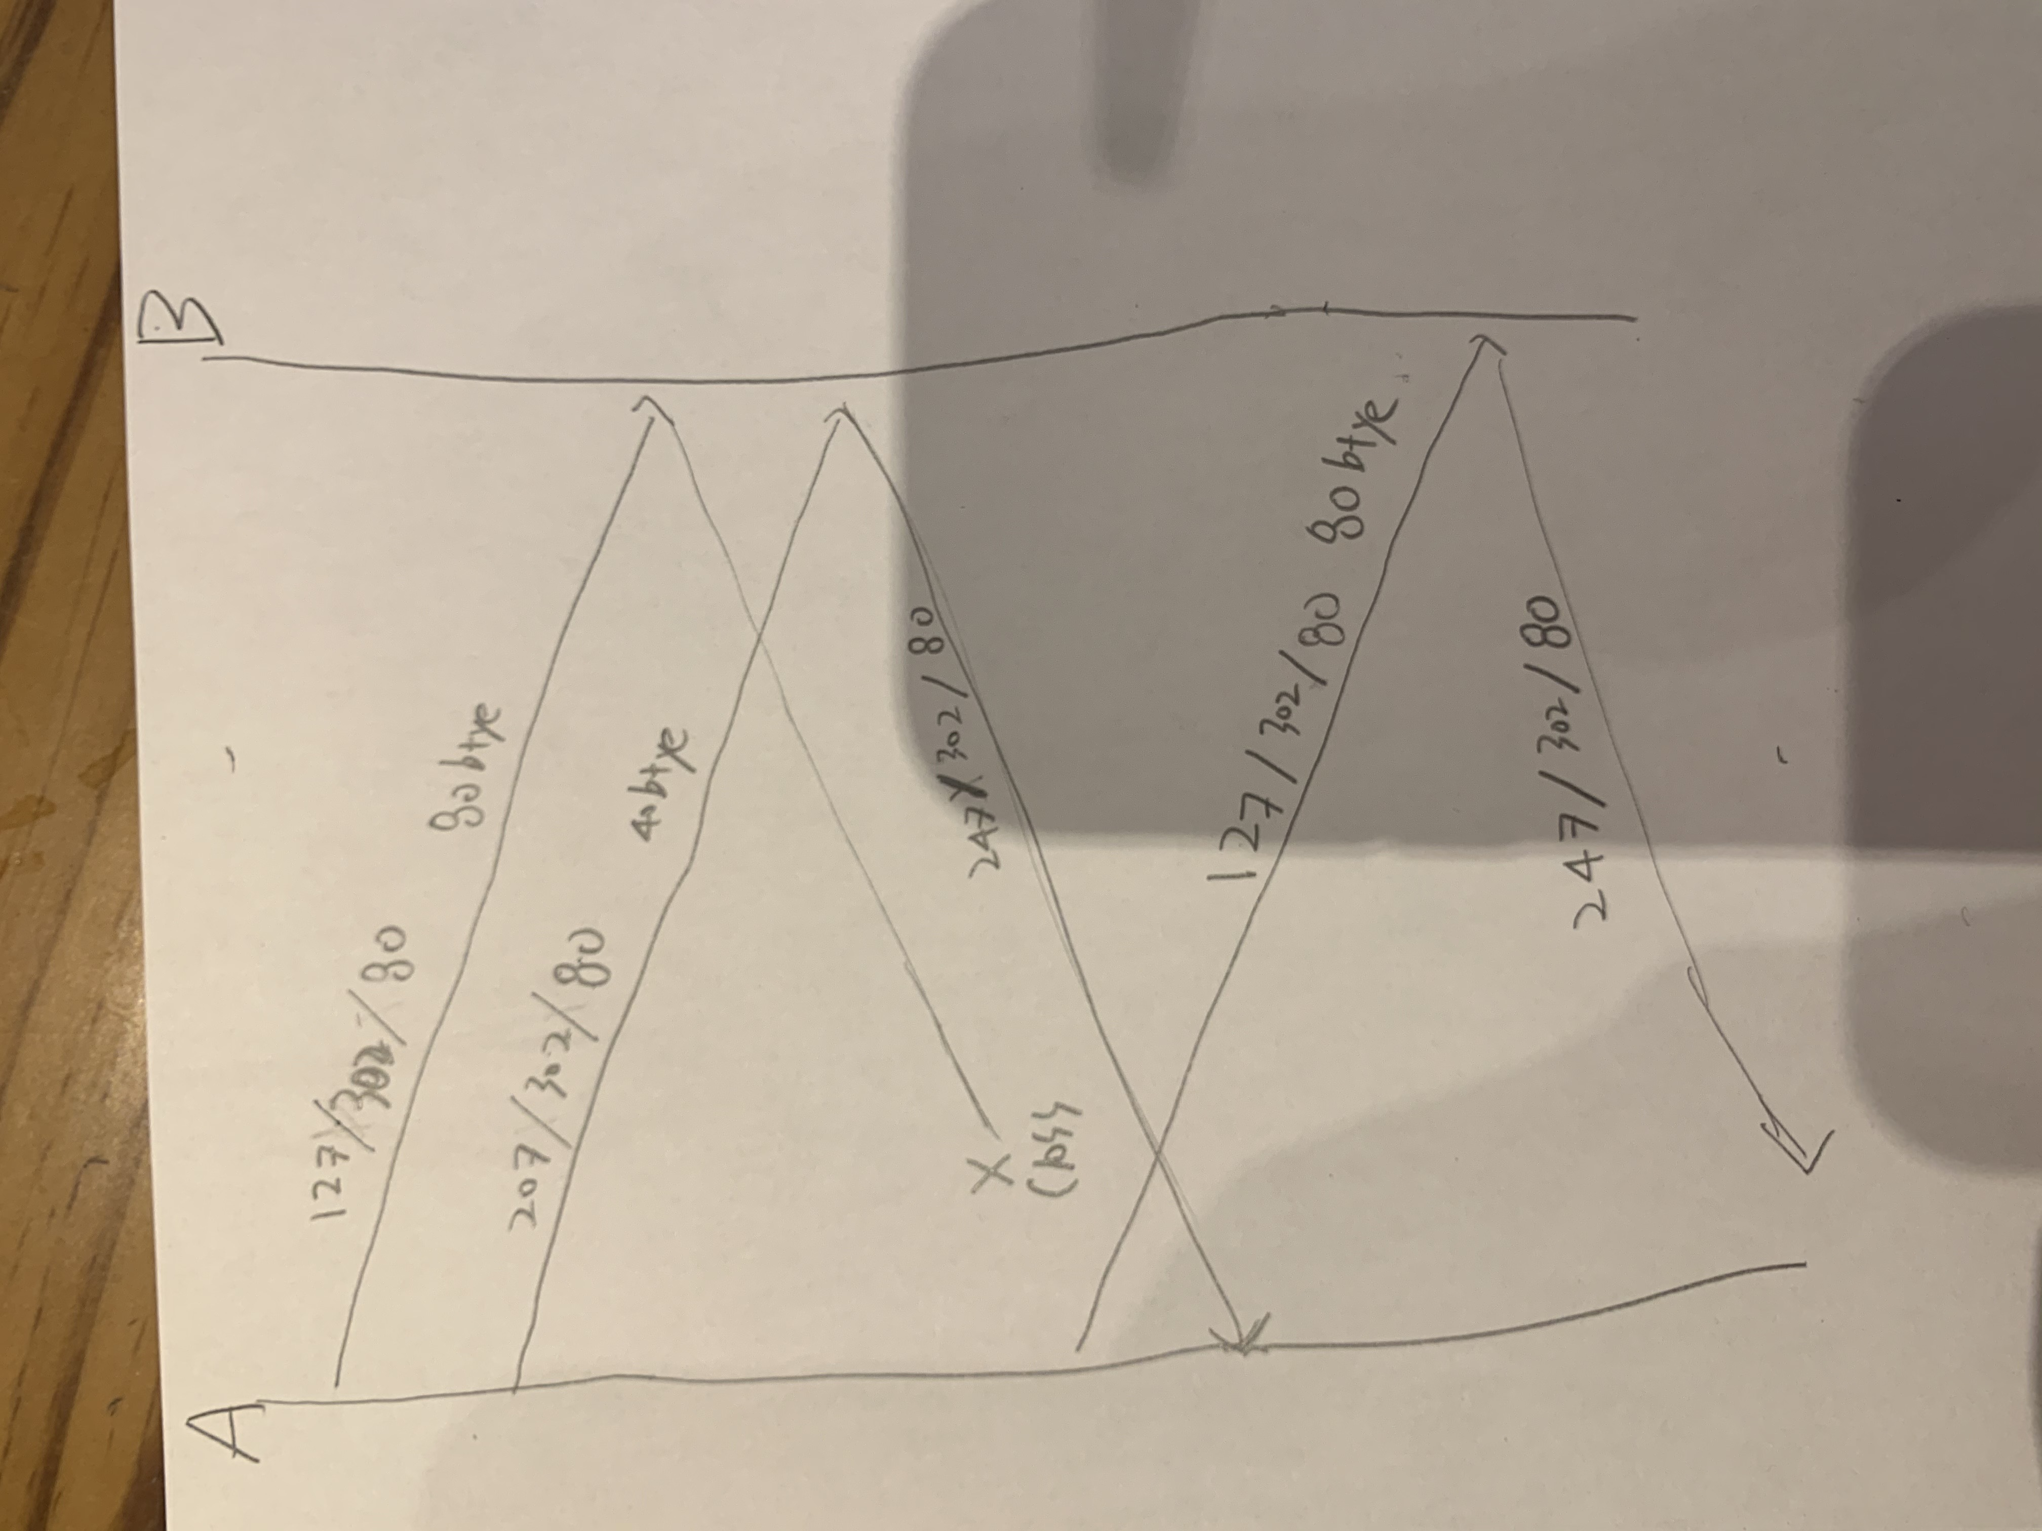

3-P28

TCP flow control can use feedback mechanisms to prevent data overflow.

3-P31

EstimatedRTT(t) = (1-a)\*EstimatedRTT(t-1) + a\*SampleRTT(t)

∴ x = 0.875 \* [100, 107.5, 103.15, 107.75, 105.53] + 0.125 \* [106, 120, 140, 90, 115]

x = [107.5, 103.15625, 107.75, 105.53, 106.715]ms

DevRTT(t) = (1-b)\*devRTT(t-1) + b\*|SampleRTT(t) – EstimatedRTT(t)|

∴ y = 0.75 \* [5, 5.0625, 8, 14.06, 14.42] +

0.25|[106, 120, 140, 90, 115] - [107.5, 103.15625, 107.75, 105.53, 106.715]|

y = [5.0625, 8, 14.06, 14.42, 12.885]ms

TimeoutInterval = EstimatedRTT + 4 \* DevRTT

∴z = [107.5, 103.15625, 107.75, 105.53, 106.715] + 4 \* [5.0625, 8, 14.06, 14.42, 12.885]

Z = [121, 135.15, 164, 163.21, 158.255]ms

3-P34

It will explain you how big the ACK is and how far the transfer is completed.

3-P35

Because it waits enough time to prevent a collision with the host that caused the crash.

3-P36

As the phenomenon must occurs, the probability of occurrence of the phenomenon is reduced by increasing the timeout critical value.

3-P40

1. 0 ~ 6 , 23 ~ 26
2. 6 ~ 16 , 17 ~ 22
3. segment loss detected by a triple duplicate ACK, because it restarts at 20
4. timeout, because it restarts at near to 0
5. 33
6. 21
7. 13
8. N = $\sum_{1}^{n}{Congestion window size(x)}$

1 + 2 + 4 + 8 + 16 + 33 < 70 < 1 + 2 + 4 + 8 + 16 + 33 + 34 ∴ N = 7

1. 4 ∵ TCP Reno starts half size of $Congestion window size$ when detecting packet loss
2. 4 ∵ TCP Tahoe restarts when detecting packet loss, so graph is similar to 1 ~ 6
3. $\sum_{1}^{6}{Congestion window size(x)}$ = 64